September 11-14, 2017 international experts from science and industry demonstrate the business value of smart data services at SEMANTiCS 2017
Amsterdam - this year’s hotspot on
Linked Data Strategies & Practices

Amsterdam, August, 2017: Experts from science and industry meet at Europe’s biggest Linked Data and Semantic Web event to present and discuss latest achievements, challenges and future perspectives of new data management practices. The conference for Semantic Systems is now in its 13th edition and run by a mixed industry and research consortium built by Semantic Web Company (Austria), Institute for Applied Informatics (Germany), University of Applied Science St.Pölten (Austria) and the dutch partners VU, TNO and Kadaster, together with Wolters Kluwer as major industry sponsor.
Most companies and public administrations nowadays are struggling to catch up with new data management practices, either by initializing a data strategy from scratch or by adjusting their old strategy to the affordances of new technological environments, legal frameworks or business models. The Semantics conference gives insights into data management strategies, discusses cases of data-driven business models and gives advice on how to catch up with latest developments at the dawn of smart, networked data.
The exchange between industry and research is facilitated by a rich program consisting of six keynotes from companies like EA Games, Wolters Kluwer, and OTTO, followed by a total of 36 industry and 25 scientific presentations, 17 workshops, a poster and demo area and numerous social side events.

Programme Overview
September 11, 2017: Pre-Conference Workshops
September 12, 2017: Main Conference Day 1:
Keynotes by Wolters Kluwer, EA Games
and Toulouse Institute of Computer Science Research
September 13, 2017: Main Conference Day 2:
Keynotes by OTTO & Ghent University
September 14, 2017: Post-Conference Workshops & DBpedia Day: Keynote by Chris Welty

This year’s conference focuses on the business value of Linked Data technologies and services as an enabling technology for a cost-efficient, flexible and sustainable enterprise data strategy.
This is addressed in the opening keynote of Sandeep Sacheti, Executive Vice President, Customer Information Management & Operational Excellence of Wolter Kluwer and in the management panel on Wednesday with Frank Tierolff (board member of Kadaster), Henk Jan Vink (director Networked Innovation of TNO), Kor Brandts (director DUO) and Michiel Borgers (Dutch Ministry of Finance).
The full and rich programme, with talks and presentations by leading researchers in the field and leading industry adopters, can be found at the conference page at http://2017.semantics.cc

SEMANTiCS 2017 Key Data

Date: 11-14 September 2017
Venue: Meervaart Theatre, Amsterdam, The Netherlands
Website: http://2017.semantics.cc
Programm: http://2017.semantics.cc/programme
Twitter: @semanticsconf
Contact: Dissemination Chair
Arjen Santema
arjen.santema@kadaster.nl
+31 (0)6 52481774

Sponsored by
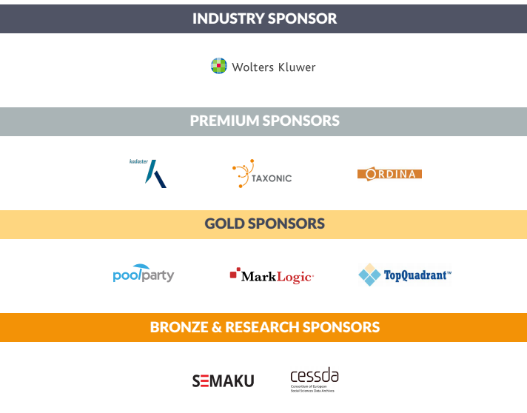
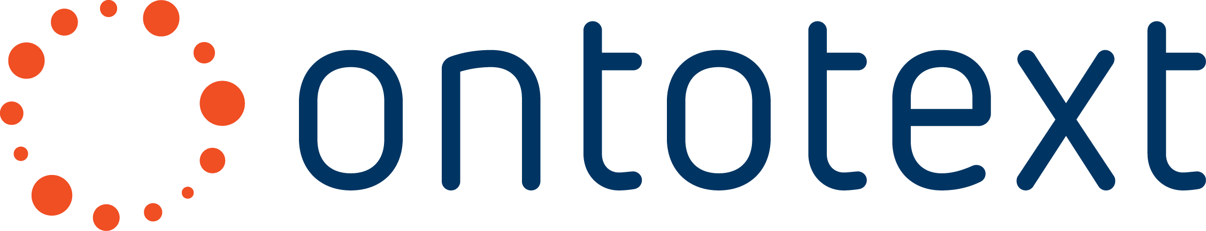
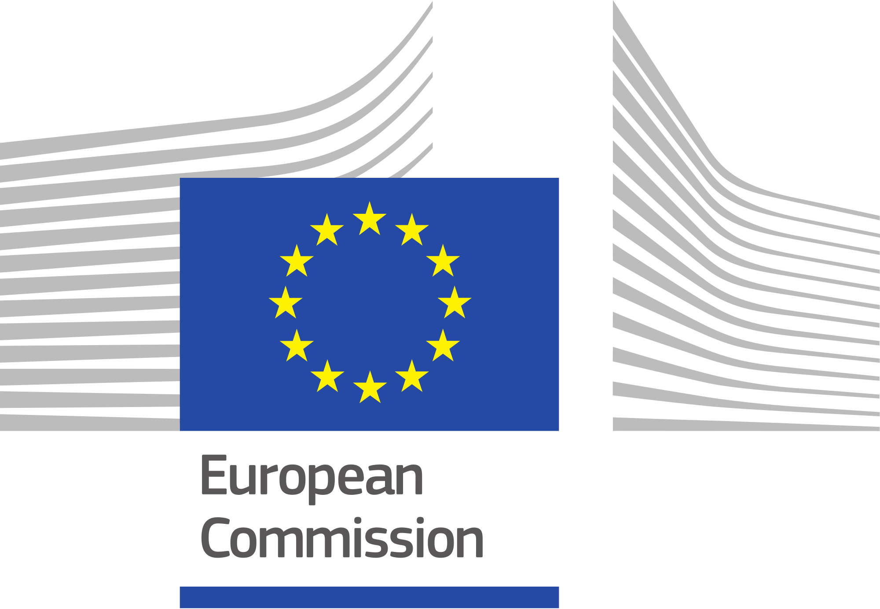

Highlights

GAME INDUSTRY

Semantics at Play: Electronic Arts’ Linked Data Journey
Aaron Bradley / Eamonn Glass
Senior Manager, Web Channel Strategy / Director, Online Platform Strategy @ EA Games

Millions of players consume or create content related to EA’s video games every day. In response EA has set about changing its approach to the creation, classification and distribution of digital content. This has entailed structurally modelling and semantically describing the content in EA’s ecosystem. This approach has allowed EA to forge an entity-based understanding of available content to provide the right information to the right player at the right time. In this talk Aaron and Eamonn will describe how they were able to initiate this journey at EA, discuss challenges and how they overcame them, share initial learnings, and look at how linked data will play a key role in the EA player network.

More info: http://2017.semantics.cc/aaron-bradley-eamonn-glass

PUBLISHING INDUSTRY

How Wolters Kluwer’s AI aided human experts deliver increasing accuracy, speed and value for our customers
Sandeep Sacheti
Executive Vice President, Customer Information Management & Operational Excellence @ Wolters Kluwer

Mr. Sandeep Sacheti has been Executive Vice President of Customer Information Management and Operational Excellence for Wolters Kluwer Governance, Risk & Compliance at Wolters Kluwer Financial Services, Inc. A well-known pioneer in data analytics, Mr. Sacheti has spent more than 15 years in customer-driven research and operations and has held a number of senior risk management, decision science and operational positions in financial services companies during that time. In his talk Mr. Sacheti will give an insight into Wolters Kluwer data-driven customer management strategy and what it needs to make a multinational company like Wolters Kluwer fit for the age of smart data.

More info: http://2017.semantics.cc/sandeep-sacheti

AGRICULTURE

Will semantics help disentangle the Gordian knot of Big Data in animal health
Miel Hostens
Data Scientist @ Ghent University, Department of Reproduction, Obstetrics and Herd Health

The use of ontologies (i.e. controlled vocabularies) is a means to make scientific descriptions more comparable. One of the main challenges in animals health is that even elementary concepts often have no canonical form which would be the preferred notation that encapsulates all equivalent forms of the same concept (eg. disease or health event definition). The semantic web could offer a common framework that allows data to be shared and reused across canonical form, application, enterprise, and community boundaries. Multiple technical and business challenges unique to the animal domain can be identified and need to be addressed before the semantic web can grow from a conceptual towards an applied framework in animal health management.

More info: http://2017.semantics.cc/miel-hostens

RETAIL

Buoyancy in Data Lakes
Agile Metadata Management in Hadoop Data Warehouses at Otto Group
Utz Westermann
Senior Data Architect @ Otto Group

Current metadata and information about data lineage are crucial for understanding and interpreting data in a Hadoop data warehouse. At the same time, Hadoop data warehouse projects sink or swim with the ability to continuously add new data sources and views as business requirements evolve. The talk illustrates how Otto Group developed an integrated view on crucial enterprise data and their collaborative data strategy. Schedoscope and Metascope drive Otto Group BI's data platform, which processes clickstream, product, and CRM data from 120 online shops with a yearly revenue north of 5bn Euros. Schedoscope has enabled Otto Group BI's small team of data engineers to continuously release new data sources and view for more than 2 years now; with Metascope, Otto Group's analysts and data scientists have access to always up-to-date metadata and documentation.

More info: http://2017.semantics.cc/utz-westermann

ARTIFICIAL INTELLIGENCE

New convergences between
Natural language processing and knowledge engineering at the era of the Semantic Web.
Nathalie Aussenac Gilles
CNRS senior researcher @ Toulouse Institute of Computer Science Research

Design the theories and systems required to process natural language (either to "understand" written or oral human language or to generate new text), or to perform reasoning and solve problems, have been two main research lines right from the beginning of AI. Today, they still form two separate research communities: Natural Language PRocessing (NLP) and Knowledge Engineering (KE). Although these activities are closely related in human cognition and activities, they have long been studied as two separate tasks that share a common background in knowledge representation and logic. THis talk will first sketch the historical relations between NLP and KE, highlighting research challenges at their confluence. It will draw an overview of the current approaches to identify semantic relations in text, with a special focus on the ways pattern-based solutions have evolved since early works, on machine learning methods and on the complementarity of various techniques to support this task. The talk concludes by stressing the need to capitalize better all the experiments and tools developed up to now, in particular by sharing not only representations and data, but also patterns and learning methods, and also by investigating more systematically how existing techniques can be used together in a single platform, and mutually benefit of each other's results.

More info: http://2017.semantics.cc/nathalie-aussenac-gilles

OTHER INDUSTRIES AND PRESENTATIONS

AIFB, Karlsruhe Institute of Technology * AIT Austrian Institute of Technology * AKSW, DBpedia Association, KILT Competence Center, InfAI, Leipzig * Austrian Federal Computing Center * Bielefeld University, CITEC, Semantic Computing Group * CITEC, Bielefeld University * CNR-ITIA * Cognitum * Cognizone BVBA * coolgate inc * CRIDA - Reference Center for Research * CRS4 * Datalan * derivo GmbH * Deutsche Telekom AG * Dhirubhai Ambani Institute of Information and Communication Technology * Enterprise Information System (EIS) * ETSI ISG CIM (supported by NEC Europe) * FontoXML / Liones * FORTH-ICS * Franz Inc. * Fraunhofer Institute for Intelligent Analysis and Information Systems IAIS * Geographical Information Management and Applications * Ghent University/imec * Hanoi University of Technology * Healthdirect Australia * Human-Centered Computing * ICS FORTH * IET - The Institution of Engineering and Technology * IK4-TEKNIKER * Insight Centre for Data Analytics, National University of Ireland Galway * Institute AIFB, Karlsruhe Institute of Technology * Institute for Geoinformatics - University of Muenster * Institute of Applied Informatics and Formal Description Methods (AIFB) / Karlsruhe Institute of Technology (KIT) * Institute of Computer Science, FORTH * Institute of Digital Games, University of Malta * Institute of software technology and Interactive Systems, Vienna University of Technology * Kadaster * Karlsruhe Institute for Technology * Knowledge Media Institute, The Open University * KnowSyms B.V. and Semaku B.V. * Koninklijke Bibliotheek, National Library of the Netherlands * MarkLogic * Mekon * National and Kapodistrian University of Athens * National Centre of Scientific Research "Demokritos", Athens * National Library of the Netherlands * National Technical University of Athens (NTUA) * Netage * Neurology, HHU Düsseldorf * NIOD Institute for War, Holocaust, and Genocide Studies * Norwegian University of Science and Technology * NUIG, galway * Ontotext * Ordina * Ordnance Survey Ireland * Organisation for Economic Co-operation and Development (OECD) * Paris Descartes University * Philips Research * ProRail * School of Electrical Engineering and Informatics ITB * SDA Research, University of Bonn * SEEK Limited * Semantic Web Company * Tata Consultancy Services, India * Taxonic * Taxonic & Semaku * TCD-Adapt * TCS Innovation Lab Delhi * Technische Universität Wien * Textkernel B.V. * TNO, The Netherlands Organisation for Applied Scientific Research * TopQuadrant,Inc. * TU Delft * U. of Fribourg * UAS St. Pölten * Universidad Simon Bolivar, Dept. Computer Science * University College Dublin * University College London * University of Amsterdam * University of Athens * University of Bonn * University of Bremen / Karlsruhe University of Applied Sciences * University of Economics, Prague * University of Fribourg * University of Piraeus * University of the Basque Country, UPV/EHU * Universy of Turin * VIAA vzw * Vienna University of Economics and Business * Vienna University of Technology * Volenta * Vrije Universiteit Amsterdam * WordLift S.r.l.

Keywords: Enterprise Data Strategy, Business Intelligence, Linked Data Services, Artificial Intelligence, Machine Learning, Supply Chain Management, Data Quality Management, Corporate Knowledge Graphs, Big Data

